Buongiorno a tutti,
Something really special has arrived from the Val d'Orcia and we are ready to share the fun!
Val d'Orcia is a wide and beautiful countryside in southern Tuscany, close to the border with Umbria and on the slopes of Mount Amiata, stretching along the agricultural hinterland of Siena. It takes its name from the Orcia river that runs along and is a protected park where the absolute protagonist is stunning nature. It is no coincidence that one of the most photographed spots is the famous Val d'Orcia cypress trees near San Quirico d'Orcia.
Crete Senesi, the clay hills eroded by time that form the characteristic calanchi (gullies) and biancane, bare and rugged, low rounded reliefs with an unquestionable, almost lunar charm, also stand out in the Val d'Orcia. Its typical medieval Tuscan villages such as Pienza, Montalcino, Castiglione d'Orcia and San Quirico d'Orcia are perfect destinations to dive into the soul of the place, while savoring its well-known food and wine specialities.
The Val d'Orcia still preserves its system of settlements, the medieval villages of Tuscany, which still attract tourists from all over the world. Made up of mainly castles and fortresses, they developed in the year 1000-1100 around the Via Francigena, the great road connecting France and northern Italy with Rome.
Places such as Montalcino, San Quirico and Castiglione were crucial to the cultural and urban development of the valley, as was also Pienza, the birthplace of Enea Silvio Piccolomini, the future Pope Pius II.
Pienza is considered the Ideal City of the Renaissance and it was Piccolomini who directed the town's urban planning choices in the 15th century.
Since 2004, the incredible landscape of the Val d'Orcia has been a UNESCO World Heritage Site. A treasure to be protected and enhanced because of the excellent state of conservation of the landscape, thanks to the human interventions that have preserved it.According to UNESCO, the Val d'Orcia Park is a perfect combination of art and landscape, geographical space and ecosystem, an expression of wonderful natural features and historical evidence.A landscape that is at times hard and soft, characterised by the lava deposits of the extinct volcanoes of Radicofani and the Amiata, enhanced by the medieval villages, scenic roads and landscapes of the Val d'Orcia.
The UNESCO site also includes Pienza.
Today's Winery spotlight is on Il Moro di San Giovanni. From the owners' words
"On a serene and beautiful afternoon of mid-May we arrived for a viewing at “Podere Il Moro” situated in a bizarre desert of variagated clay, nestled in the heart of the “Crete Senesi”. It was a love at first sight, so much so that we immediately began calculations. Just how many hectares would we require to plant new vines and start again making our own wine…Once again to share this adventure that both our families had so enjoyed. Impossible to resist, a few days later Il Moro was ours and the daring challenge was whether or not to plant international vines instead of native ones. What to do?
Courage and tradition are to me, are the principal characteristics of this world from which for a period I had inevitably detached myself.
It is said that being surrounded by beauty influences our thoughts, our wishes and, our life… I agree.
My passion for art, wine and music has accompanied me throughout life but, what has brought to me new ideas has always been locations where I have had time to pause for thought. Magical places with a pure and positive energy. Regardless of whether at the time I barely touched them, it is how they touched me that made the difference. They have taught me to observe, think, change and ultimately return to them".
The vineyards are located on clayey-limestone soils on the top of hills with a gentle profile. Particularly windy in San Giovanni d’Asso (Municipality of Montalcino) and in Monticchiello (Municipality of Pienza). Respectively at 300 and 500 meters above sea level. The exposure of Monticchiello generates a warmer microclimate with greater excursions between day and night, particularly favorable for the cultivation of Petit Verdot. In 2003 they planted the first vines of Cabernet Franc, Cabernet Sauvignon, and Petit Verdot, using vine cuttings from Bordeaux. In 2004 they planted another hectare of Petit Verdot in Monticchiello.
The Val d'Orcia does not get the same worldwide wine recognition as Montalcino or Montepulciano, but the place is truly magical and the wines are as well.
At Il Moro di San Giovanni the purpose was always to make world class wines that could age for a long time and be open after several years of bottle (affinamento) refinement.
We at PSP (https://pspglobalwines.com/), have been proud to represent their wines and bring them to Massachusetts (the only market in the US) for years. Every year, waiting for the "new" vintage release has been like a New Year's Eve celebration and finally we got the 2012 Il Moro di San Giovanni IGT (but we also have a little 2011 to share).
With the new arrival we also got some large formats and I wanted to put out a fun offer for anyone interested.
Purchase a case (12pk) of 2012 Il Moro di San Giovanni and receive 2bt of 1.5lt Il Moro di San Giovanni 2010, or purchase a case of 2011 Il Moro di San Giovanni (6pk) and receive 1bt of 1.5lt Il Moro di San Giovanni 2010!!!!
FIRST COME FIRST SERVE as we have limited amounts of cases
2012 Il Moro di San Giovanni IGT - 13cs available
$480 to $440 12pk (and get 2bt of 1.5lt 2010)
2011 Il Moro di San Giovanni IGT - 92 RP - 6cs available
$240 6pk (and get 1bt of 1.5lt of 2010 or double up for 2 1.5lt!)
Don't miss out on these stunning wines
Ciro Pirone

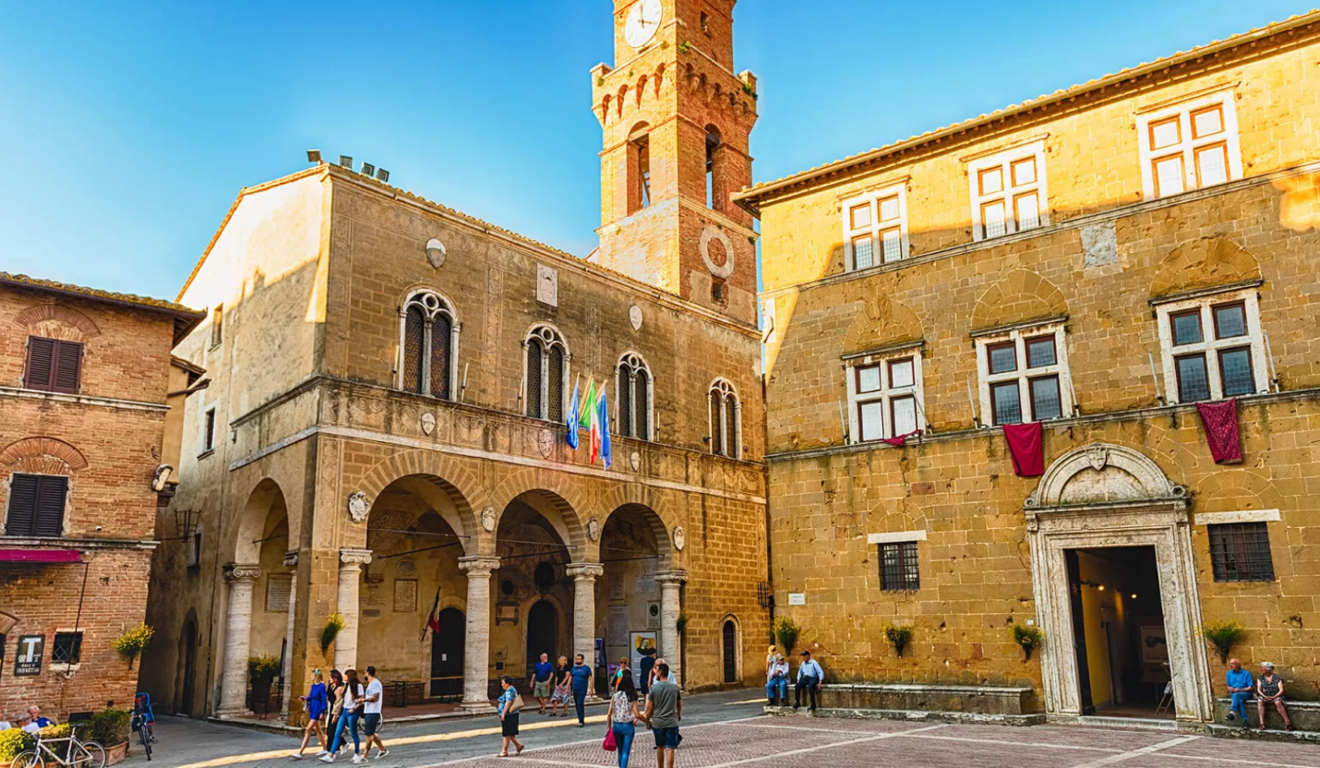

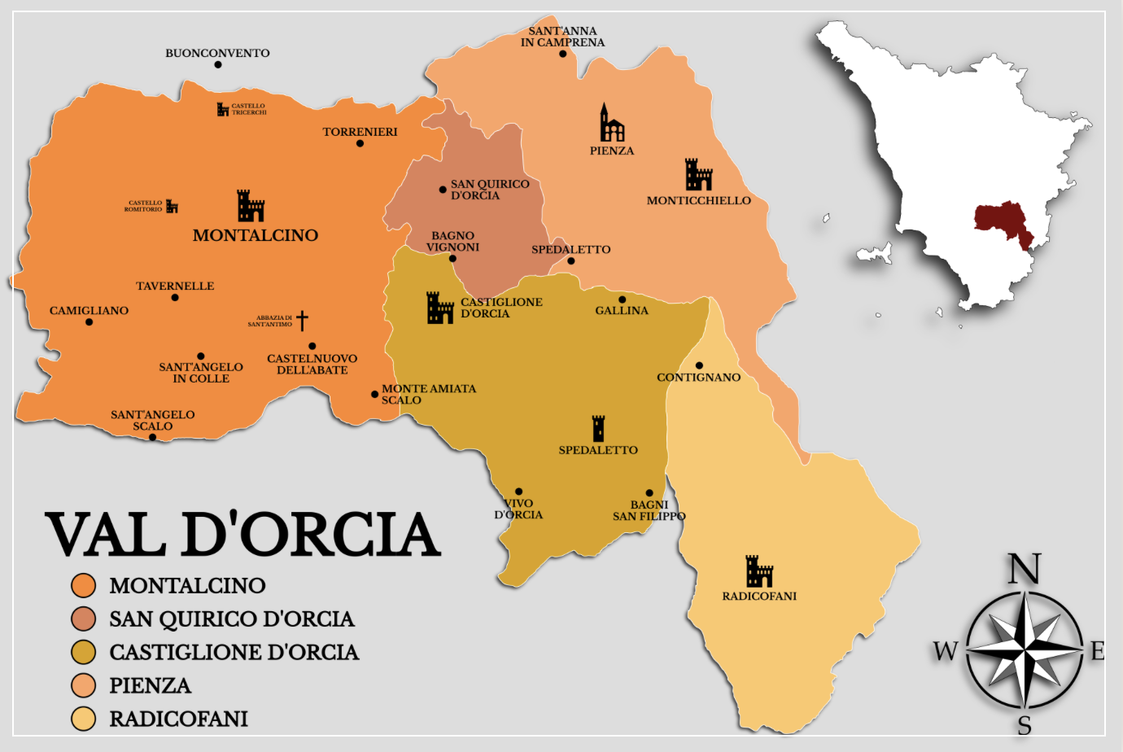
The above map shows the villages that are part of the Val d'Orcia, including the famed Montalcin0.

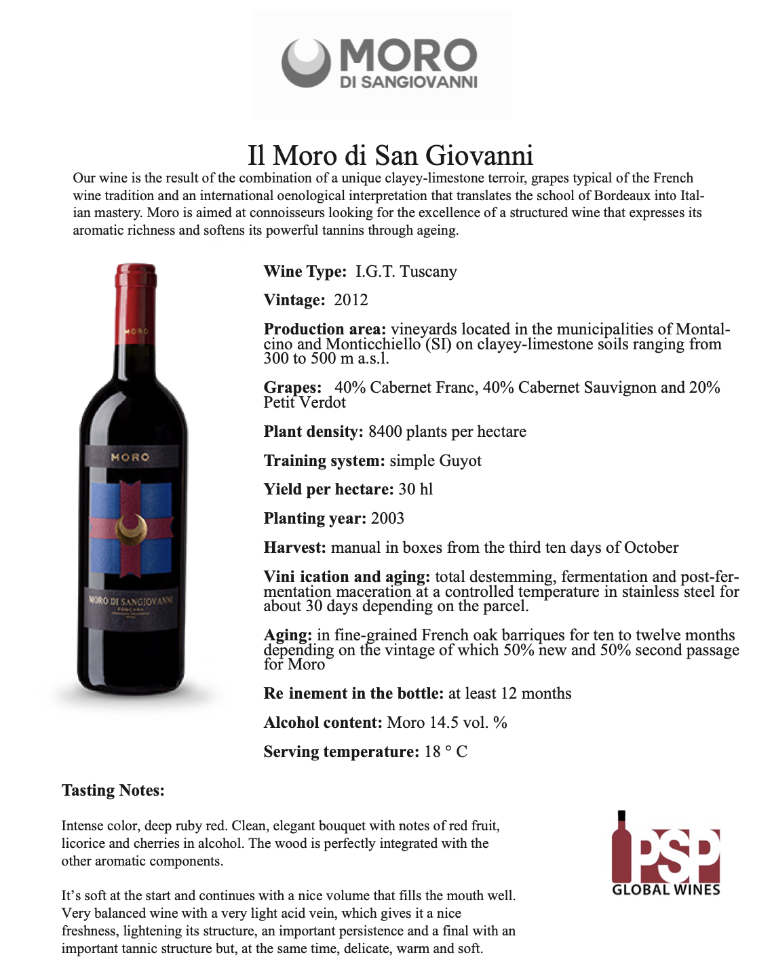
The 2012 NEW release

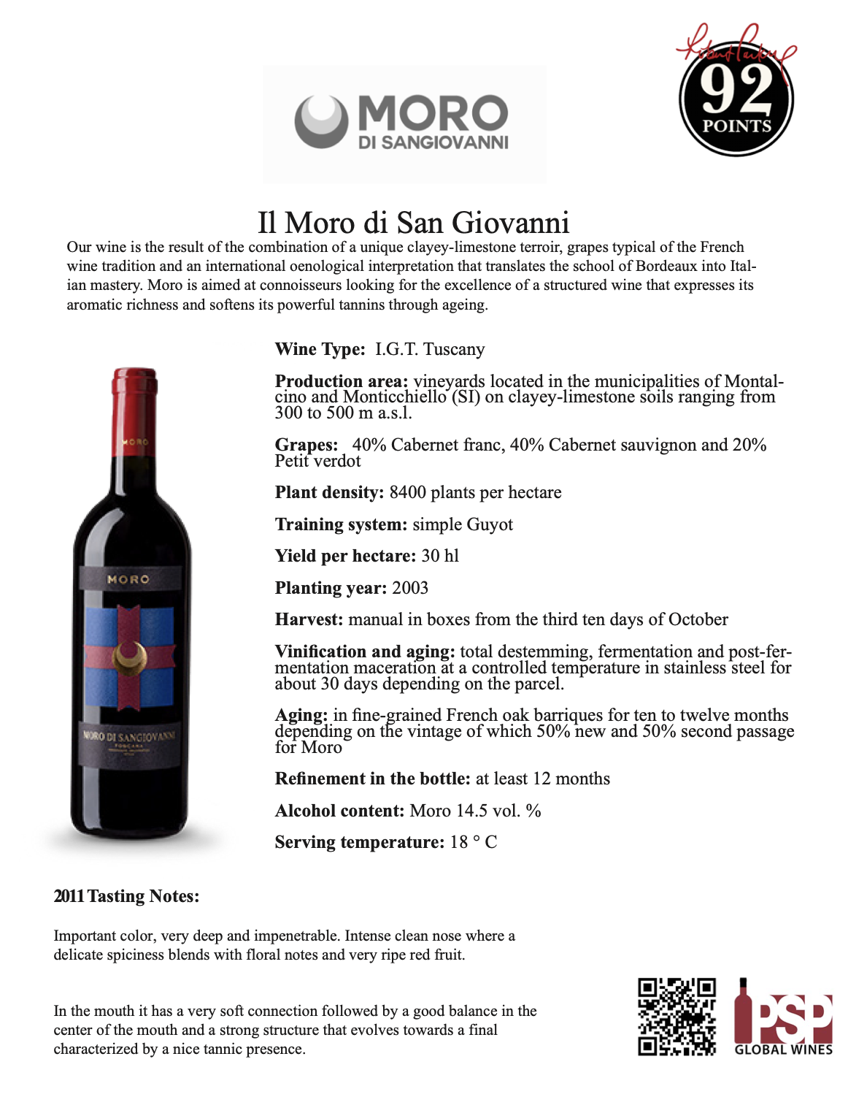
THE 2011 vintage

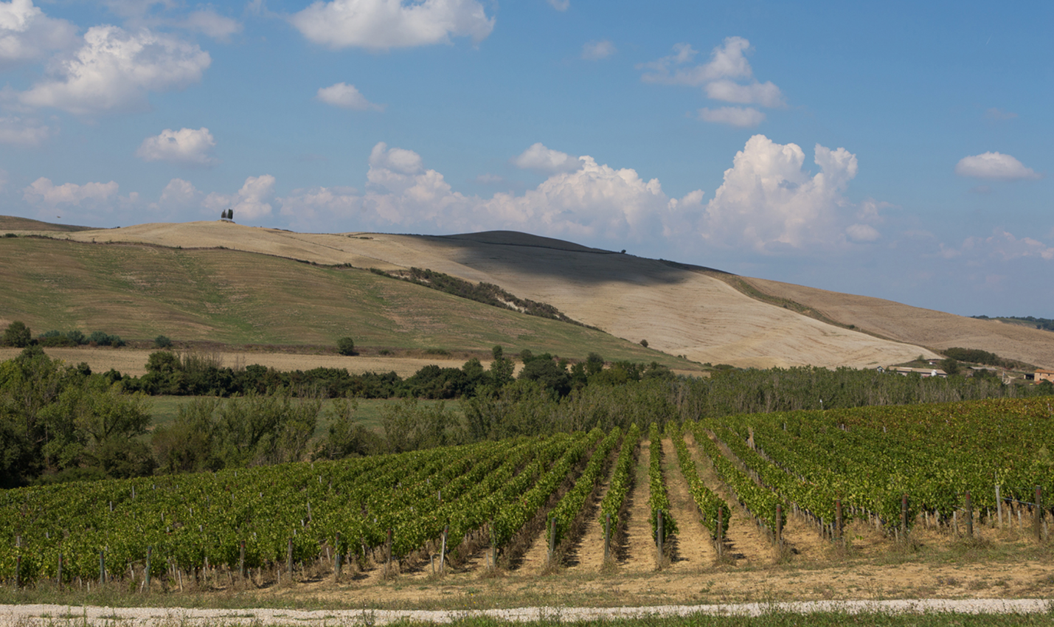
Above is a picture of the vineyards of Petit Verdot at Il Moro di San Giovanni, while below is the clay rich soil of the estate.

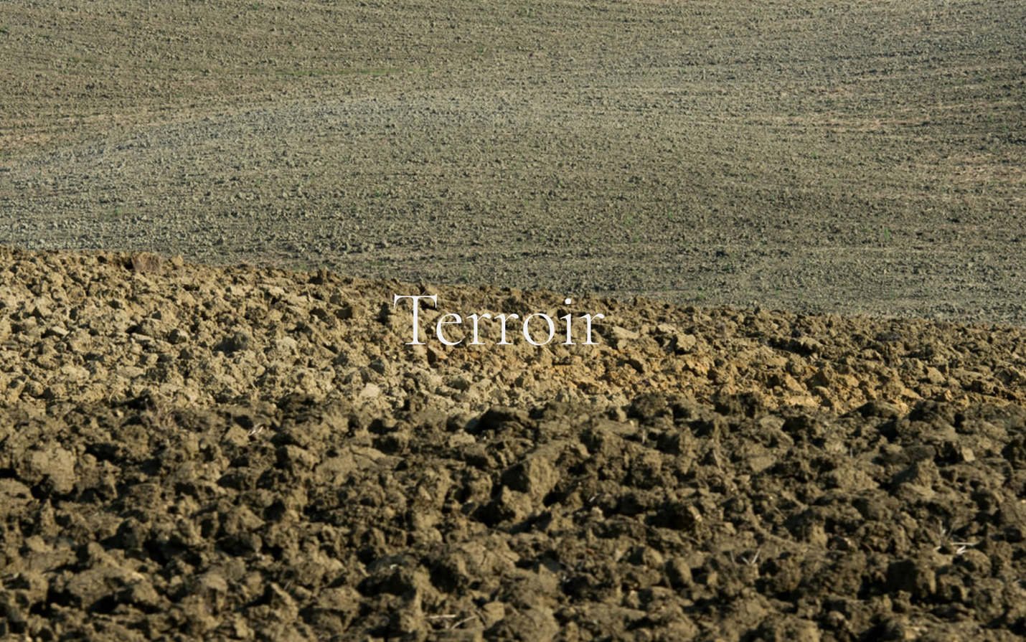

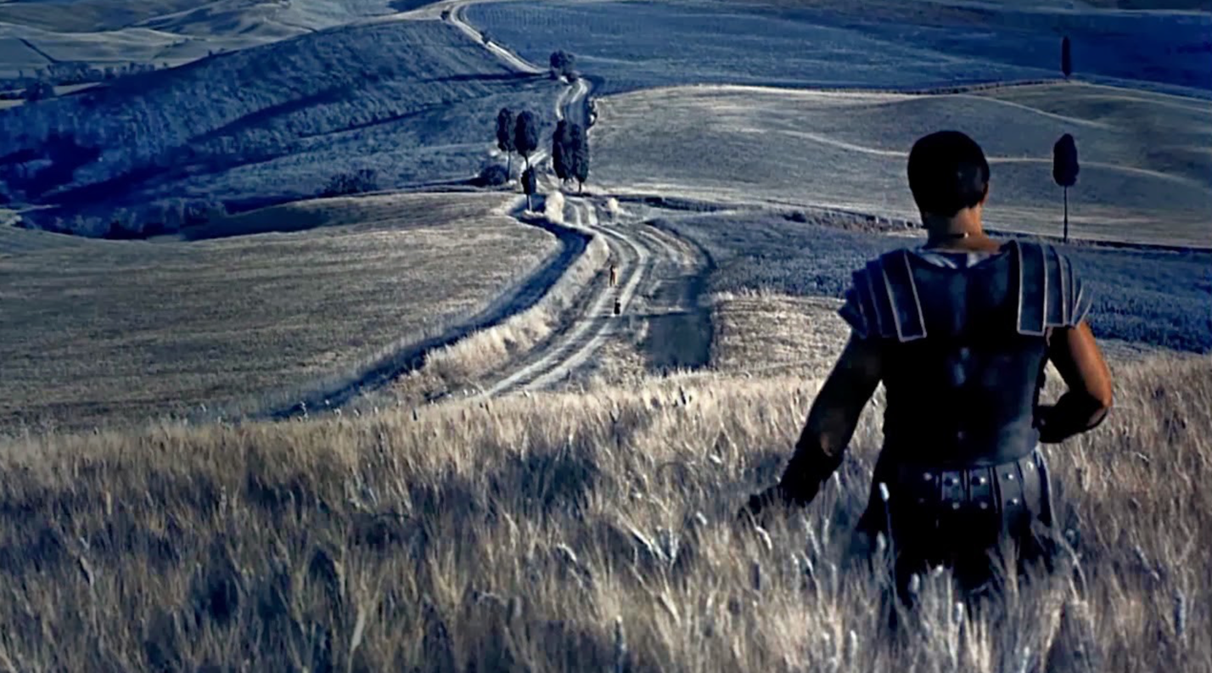
FUN FACT: parts of the movie THE GLADIATOR were filmed in the Val d'Orcia and specifically Maximus' house is located at the entrance of San Quirico d'Orcia.

The scene

